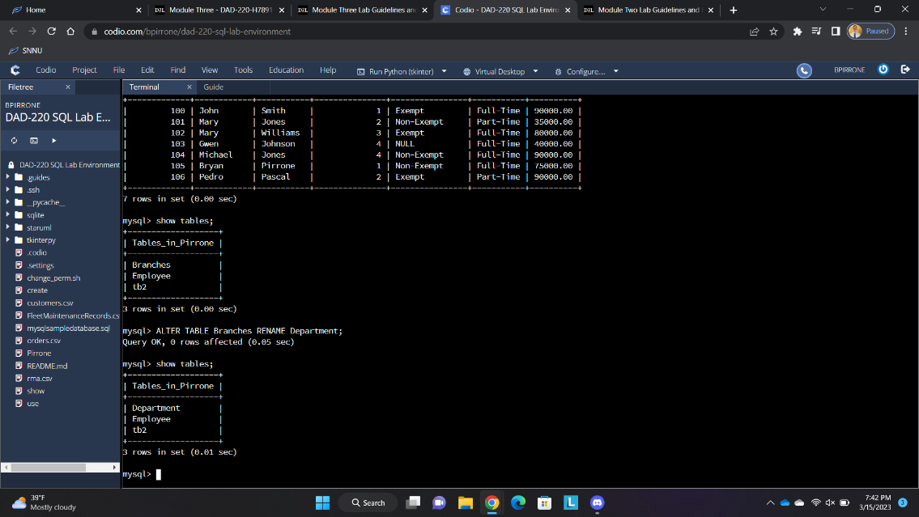

I utilized the alter statement seen above to change the table branches to department.

I used the select statement seen above to set the fields representing the four department IDs that I utilized last lab to be the following departments: Accounting, Human Resources, Information Systems, and Marketing.

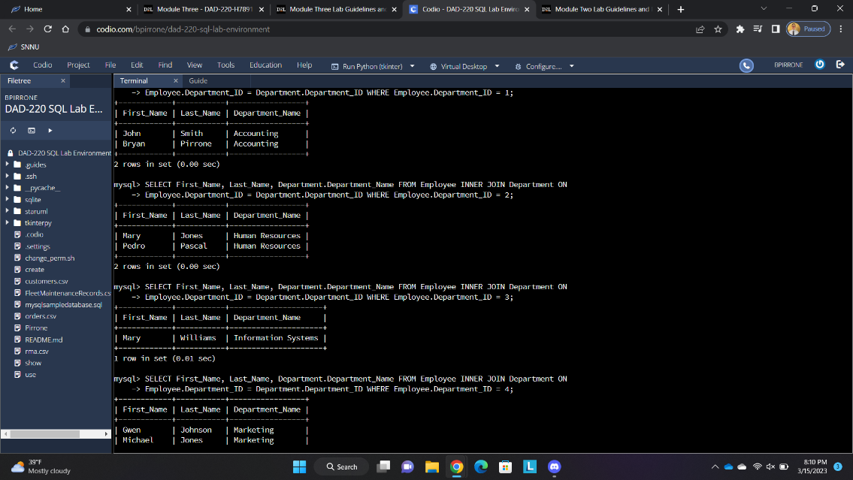

I then performed inner joins between Department and Employee to display the employees in each department.

I then added eleven more employees and filtered them out by department as in the previous step. The number of employees was seven previously and I added eleven more employees, and the results show the correct formatting for the new employees. There are now five employees in marketing, five employees in human resources, two employees in information systems, and five employees in accounting.

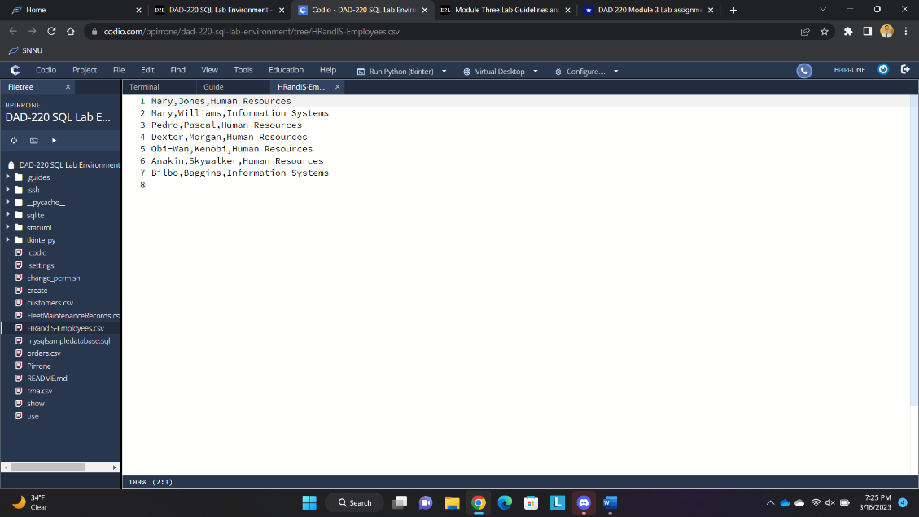

Lastly, I created a csv file and printed it’s output. This is seen in the image above.

Reflection:

In the first part of the assignment, I altered the Branches table to be named Department. The join command that I used between the Employee and Department combined them into a single table based on Department ID and showed me which employees are in which departments. By renaming the table to Department and inputting the new fields with Department IDs, the join was able to correlate employees and their Department IDs from the Employee table with the corresponding Departments from the Department table.

File Creation and Extraction:

There were seven employee outputs when I created the csv file. There are five employees in the Human Resources department and two employees in Information Systems department. The process to extract data to a flat file is accomplished by using a command query to extract the requested data from a specified table.